Army Squash

Coaching Strategy

Vn 1.0 20 Apr 20

**Coaching Vision**

*“A network of qualified and capable Army Squash coaches delivering regular coaching for players of all standards, from grass roots to elite, across all Army bases.”*

**Introduction**

1. Army Squash has made a number changes over the last three years to improve the governance, management and development of players, forging closer ties with England Squash and the Professional Squash Association. Talented Army players are now being mentored and developed through the Academy programme; the next step is to provide a coaching programme that can be accessed by all players, from absolute beginners to Corps and Army players.

**Issue**

1. The current (publically funded) squash coaching course does not target talented squash players that can move to the coaching programme, qualified coaches are not recorded and coaching activity is not tracked. The aim of qualifying coaches should be to deliver coaching to military personnel – this aim is not being delivered, or tracked. There is no means of a squash player, or potential squash player, to access military squash coaches.

**Aim**

1. The aim of this strategy is to outline a plan to:
   1. Identify potential coaches, ensure that there is an obligation on those attending the coaching course to ‘give back’ by using the qualification to develop new and existing players within the Army.
   2. Provide the training courses required to qualify identified coaches.
   3. Provide the funding for advanced coaching courses (currently not publically funded).
   4. Develop a network of coaches and players that spans every major military location utilising the Army Squash website.
   5. Maintain a database of qualified coaches and the players they are coaching.
   6. Identify talented coaches to be advanced to the next coaching level.

**Key Posts**

1. Two key posts are essential to turning this strategy into reality. The Terms of Reference for the Head Coach and Coaching Coordinator are shown at Annex A.
2. **Head Coach**. The Head Coach has overall responsibility for the delivery of the AS Coaching Strategy, most notably a coaching network and coach development programme, and for coaching the AS teams and the AS Academy. They will be assisted by the AS Coaching Coordinator and Permanent Secretary. Due to the significant time commitment required of this role, and the KSE required, this position will be filled by a professional civilian coach.
3. **Coaching Coordinator**. The Coaching Coordinator will assist the Head Coach with the planning and delivery of all coaching activities and be responsible for the day-to-day management and administration of the coaching network and development programme.

**Short Term Goals**

1. **Level 1 & 2 Coaches**. Establish a database of all qualified level 1 and 2 squash coaches.
2. **Initial Contact**. Establish contact with all known coaches and log locations – assess geographic areas of ‘need’. Establish the level of commitment from qualified coaches and details of military personnel being coached.
3. **Funding**. Provide coaches with funding to buy coaching aids, balls (training balls and competition balls), targets etc.
4. **England Squash Registration**. Establish a mechanism for all AS coaches to register with England Squash to enable them to access NGB coaching resources. Once established, this should be mandatory for all AS coaches.
5. **Communication Campaign**. Clearly communicate the opportunities for potential coaches to receive training, and for players of all standards to access free group or individual coaching from AS coaches. Initially the communication campaign will focus on:
   1. **AS Website**. Provide coach details filtered by location and qualification (example at Annex A). Each coach will provide contact details, coaching locations and available times (weekly/monthly schedule).
   2. **Social Media**. Use of Twitter and Facebook to advertise the coaching opportunities.
   3. **Defence Connect**. Use of Defence Connect to provide an environment for collaborative work, coach details register and calendar of events.
   4. **Poster**. Produce a general poster detailing coaching opportunities for players and potential coaches for distribution to all units – aim to have the poster displayed in all Gyms and Squash Court areas.

**Long Term Goals**

1. **General**. Having established a strong network of coaches and players it is important to continue to develop the network, track progress and identify talented coaches that can progress to Level 2 and 3.
2. **Coaching Courses**. The Head Coach and Coaching Coordinator must be integrated into the coaching course selection process to ensure that the right players are identified and selected. The general requirements are:
   1. **Playing Ability**. The best coaches are not necessarily the best players. However to be a good coach a reasonable playing ability is required. The minimum level for a coach is set at top 15 in a Corps, or Squash Levels 1500 points.
   2. **Commitment**. Those attending a coaching course must thereafter commit to providing free coaching to military personnel at least once a month but ideally weekly (Wednesday sports afternoons).
   3. **Coaches Network**. The application form for the course to be amended to include a commitment to join the coaching network, permitting their contact details to be included on the Army Squash website and informing the Coaching Coordinator of address changes.
   4. **Player Details**. Each coach will be required to maintain the details of the players being coached. Players being coached should be encouraged to play team squash, military and civilian and enter Army competitions.
3. **Talented Coach Development**. The Head Coach is responsible for identifying the most committed and talented coaches that should be put forward for England Squash Level 2/3 coaching qualification.

**Tasks**

1. To setup the coaching network a number of tasks must be completed to set the foundation for future development.
2. **Website**. The Secretary is to setup a coaching page (accessible via Defence Connect) containing a table of qualified coaches with the following details:

* Rank and Name
* Coaching qualification held
* Location
* Contact email
* Contact number (military)
* Group coaching day(s)/time(s) and location

1. **Coaching Data**. Initially using JPA as a reference source create a list of those military personnel that hold a coaching qualification. Make initial contact with coaches and request commitment to the coaching network, maintain a list of coaches, their commitment and details (to populate the database).
2. **Player Data**. Each committed coach to create a list of players being coached and be prepared to report progress annually as follows:

* Number of players coached – calendar year
* Number by standard (Novice, Unit, Corps, Army levels)
* Summary of coaching activity (hours of coaching delivered, success, additional resources required)

1. **Poster**. A poster to be distributed to all units detailing the coaching programme and how to find local coaches.
2. **Coaching Course Application Process**. Engagement with the ASPT to change the application and screening process for all coaching courses.
3. **ASPT Course syllabus**. Engagement with ASPT to ensure public funded courses are appropriate, valid, and correctly accredited with the NGB.

**Conclusion**

1. Army Squash is in a particularly strong position with player numbers on the increase and a high level of squash at Army level. The coaching network is vital to identify and develop talented players, increase awareness of the sport and overall participation.

<<Original Signed>>

R J Green

Lt Col

Chairman Army Squash

Annexes:

1. Army Squash – Coaching Strategy Terms of Reference
2. Example - Geographic Locations – Number of Level 1 Coaches

Annex A

AS Coaching Strategy

dated 20 Apr 20

**ARMY SQUASH – COACHING STRATEGY TERMS OF REFERENCE**

1. In order to successfully deliver the Army Squash Coaching Strategy the following Terms of Reference (TOR) apply to the key facilitators.

**HEAD COACH TORs**

1. The Army Squash (AS) Head Coach is a member of the AS Executive Committee and has overall responsibility for the delivery of the AS Coaching Strategy and coaching for the AS teams and the AS Academy. They will be assisted by the AS Coaching Coordinator and Secretary.
2. The Head Coach’s primary role is to deliver the AS Coaching Strategy, notably to include a coach development programme which will ensure there are enough Level 1, 2 and 3 coaches to meet the needs of AS. Specified tasks are to:
   1. Develop a network of Army Squash coaches to facilitate delivery of regular squash coaching at garrison locations across the Army, appointing regional coach leads as required. Maintain and monitor this network using the ASCB Army Squash website. Undertake appropriate succession planning.
   2. Ensure delivery of sufficient coaching courses (L1, 2 & 3) to meet the needs of AS; this must include at least two L1 and one L2 coaching courses per year.
   3. Identify potential coaches and support them in gaining the L1 qualification. Once qualified, support, facilitate and monitor their coaching contribution to AS and the wider Army.
   4. Identify and support talented and willing AS coaches to achieve the L2 and L3 qualifications.
   5. Monitor and assess the standard of squash coaching delivery by Army Squash coaches by facilitating periodic coach development activity in the form of regional training camps for beginner and intermediate players, coached by AS L1 and 2 coaches (10 days per year). Provide feedback and advice to coaches at the end of each activity.
   6. Serve as liaison between AS and England Squash on all matters related to coaching.
   7. Support engagement with and recruitment of junior players from the England Squash national and regional programmes. Publicise Army Squash amongst civilian clubs, players and squash affiliated organisations whenever possible.
   8. Assist in the formulation and publication of AS policy as directed by the Chairman. This will include the governance and management of the Coaching Strategy within Army Squash. Advise the AS Committee on all matters related to coaching.
3. The D of C’s secondary role is to deliver elite coaching for the AS teams and Academy; this includes:
   1. Attendance and match coaching at key competitive events:
      1. Inter-Services team and individual events (4 days per year).
      2. Inter-Corps Championships including AGM (2 days per year).
      3. Inter-Unit Championships (2 days per year).
      4. Individual Championships (2 days per year).
   2. Delivery of periodic collective training events open to the four Army teams, Academy players and selected development players.  This is to comprise eight days per year including one event to prepare selected players for the annual Inter-Services team event.  At least three days must be delivered in York/Catterick/Harrogate/Manchester.  These events should also be used as opportunities to develop Army L2 coaches.
   3. Delivery of 2 days per month of individual (or small group) coaching for Academy players, and other Army or development players within capacity.  Individual coaching should be accessible to players based in York/Catterick/Harrogate at least every other month, and in Scotland whenever this can be linked to other commitments.
   4. Develop and monitor individual training programmes for Academy players.
   5. Assist in the development of a generic training programme (and associated resources) accessible al all squad members.
4. Estimated breakdown of coaching days per year against output:

|  |  |  |  |
| --- | --- | --- | --- |
| Serial | Activity | Days | Remarks |
| 1 | Administration of coaching network and qualification pathway | 6 |  |
| 2 | Attendance at key competitive events | 10 |  |
| 3 | Academy coaching | 24 | 15 hours/2 days per month |
| 4 | Coach development activity | 15 |  |
| 5 | Collective training for Army teams | 8 |  |
| 6 | Recruitment and engagement activity | 1 |  |
| 7 | Planning, meeting attendance, etc | 6 |  |
|  | Total | 71 | @ £250 per day = £17,750 |

1. Terms and conditions:
   1. Day rate is inclusive of subsistence costs; at events where subsistence is provided at AS expense, the D of C will be provided for in the same way as committee/team members.
   2. Mileage will be reimbursed at 45p per mile when the D of C is travelling purely for AS purposes only; whenever possible events should be scheduled alongside commitments with other employers (such as England Squash) to reduce travel mileage. This will be monitored by the AS admin assistant.
   3. When overnight stays are required, accommodation will be provided in military accommodation (where available) or local hotels. For certain events the D of C will also be invited to stay with committee members. Effective forecasting of multi-day events will be required to ensure accommodation costs can be minimised.

**COACHING COORDINATOR TOR**

1. Refine and annually update the Army Squash Coaching Strategy in consultation with the Head Coach and AS Chair.
2. Act as liaison between AS and Corps Squash Secretaries and Chains of Command (CoC) to identify and encourage Squash coach participation, progression and provision of organised squash training sessions at unit level.
3. Utilise social media and communication channels to raise the profile of good news coaching stories and proactively advertise the range of squash coaching opportunities within the Army.
4. Maintain a register of Squash coaches and their coaching qualifications across the Army and advise CoCs on the suitability of candidates for squash coaching progression. This is to include details of players they are coaching and squash coaching session timings and locations.
5. Administration of coach development events, including booking accommodation and courts as required.
6. Support (in person whenever possible) the AS Head Coach in delivery of coach development events.
7. Manage the Annual Squash Coaching Budget (ensuring appropriate managerial checks are adhered to) and provide, to the AGM, an end of season report on coaching activity for each 12 month period.
8. Submit an annual budget with a business case for future funding supported by a coaching plan for the following year.

Annex B to

AS Coaching Strategy

dated 20 Apr 20

**Example - Geographic Locations – Number of Level 1 Coaches**

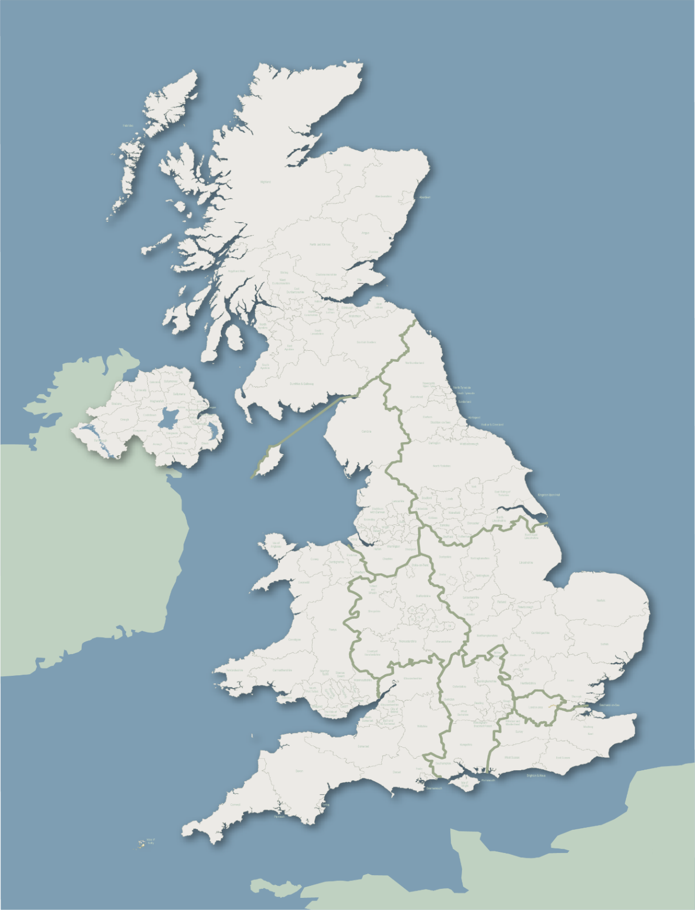



Aldershot 2

Woolwich 1

Maidstone 1

Bulford/Tidworth 5 3

Andover 3